



Project Title Library Management
PRACTICAL FILE

Object Orientend Programming with C++
(CSE-2001)

k

Name : Adhikari Viswa Teja Reg n.o : 24MIM10138
Submitted to : Dr. Dhereesh Soni Slot :A11+A12+A13
System

Introduction to Problem Solving (CSE1021)


Name : Sai Kumar Reg n.o : 25MIB10027
Submitted to : Dr. Dheresh soni

Slot :A14+D11+D12

Name : ANGERU JEEVAN REDDY
Reg n.o : 26MIP10036
Submitted to : DR.PRISCILLA DINAKAR MOYA
Slot :B11+B12+B13+C14+E11+E12

Introduction
The Library Management System is a Python-based application designed to handle essential library operations such as adding books, borrowing books, returning books, and searching for books. The system uses lists and dictionaries to store book data and offers a clean, menu-driven interface for easy use.
It is ideal for beginners learning Python and basic software development concepts.

Problem Statement
Managing books manually in a library is time-consuming and leads to errors such as misplaced records, difficulty in searching, and wrong availability status.
The goal is to build a simple digital solution to automate basic library tasks.

Functional Requirements
These are features the system must perform:

  - Add new books with title and author.

  - View all books with their current availability status.

  - Borrow a book (mark as not available).

  - Return a book (mark as available).

  - Search books by title or author keyword.

  - Exit the application safely.

Non-Functional Requirements
  - Usability – The system should be simple and easy to use for beginners.

  - Performance – The response time should be fast for all operations

  - Reliability – Must correctly update the availability status of books.

  - Scalability – Should allow unlimited number of books.

  - Portability – Works on Windows, Mac, or Linux with Python 3.

  - Maintainability – Code is modular and easy to extend.

System Architecture
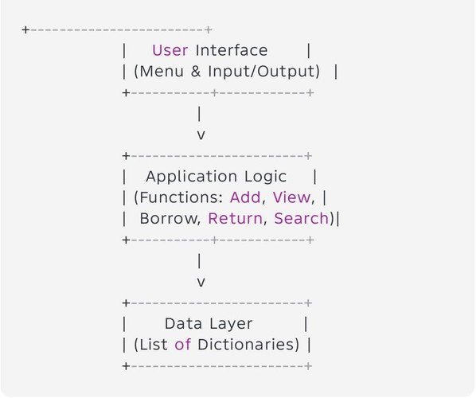

Design Diagrams
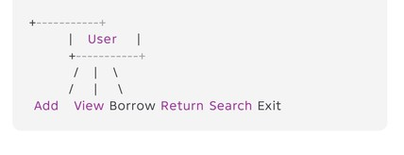
  - Use Case Diagram
  - Workflow Diagram
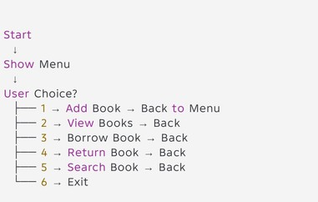

Sequence Diagram
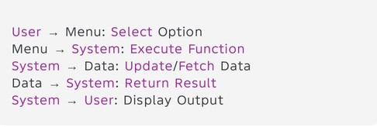
  - Class/Component Diagram
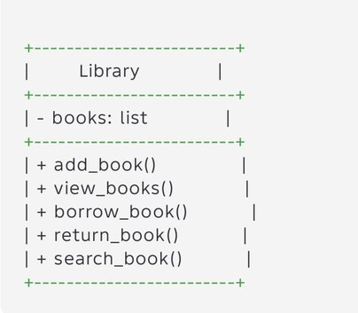

  - ER Diagram (if storage used)
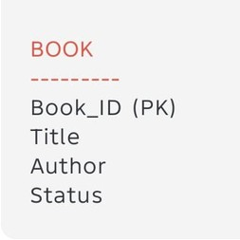

Design Decisions & Rationale
- List & Dictionary chosen — easiest structure for beginners.

- Menu-based interface — reduces complexity.

- No database — makes it simple and portable.

4 .separate function — improves readability and debugging.

Implementation Details
Programming Language: Python 3 Data Structure: List of dictionaries
Modules Used: None (only built-in features) User interacts using simple CLI prompts (input()) Each book stored as:
{"title": ..., "author": ..., "available": True}

9. Implementation Details Programming Language: Python 3 Data Structure: List of dictionaries
Modules Used: None (only built-in features) User interacts using simple CLI prompts (input()) Each book stored as:
{"title": ..., "author": ..., "available": True}

Screenshots / Results

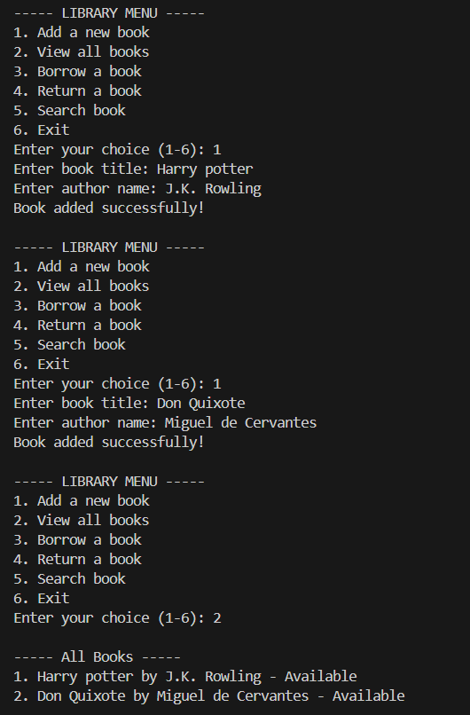

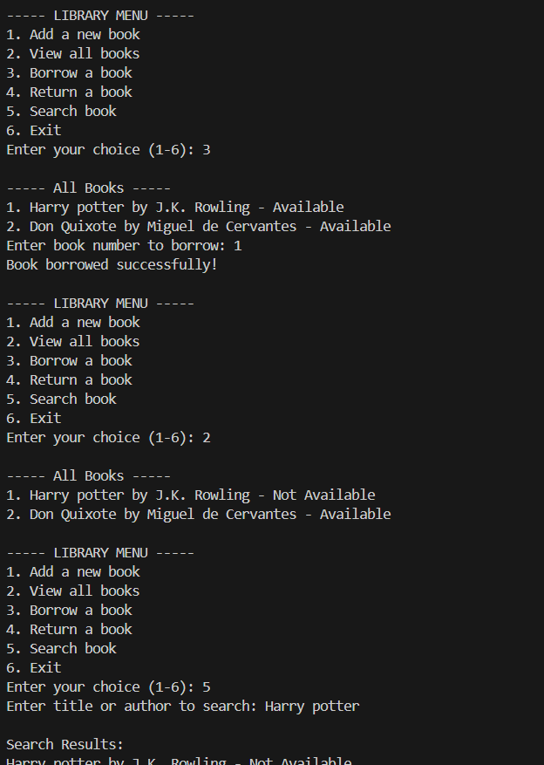

Testing Approach
Types of Testing Performed:
Functional Testing (each option tested)
Boundary Testing (empty list, invalid book number) Input Validation (incorrect input)
Integration Testing (functions working together)

Test Cases:
Test Case Input Expected Output Add book Title + Author Book added
Borrow invalid number 999 Error message
Search “Harry” Keyword Matching books

Challenges Faced

Handling invalid user inputs (like wrong numbers). Maintaining book status (available/not available). Ensuring the menu loop runs properly without crashing.

Learnings & Key Takeaways

Learned how to use lists and dictionaries effectively.

Gained understanding of modular programming using functions. Understood basic software architecture and diagrams.
Learned how console-based applications work.

Future Enhancements

Add permanent file storage (CSV/JSON). Add book IDs and user ID system.
Add login system for admin & users. Implement GUI using Tkinter.
Add due date + fine calculation.

Convert into a full web app (Flask/Django).

References

Python Documentation – https://docs.python.org Online Tutorials – W3Schools, GeeksForGeeks Class Notes & Materials

